Student Name: Muhammad Saffan Khan  
Student ID: 20026565

**Easy Drive Rentals Website Development Report**

1. **Introduction:**

Easy Drive Rentals is a car rental service designed to offer customers a seamless experience when renting vehicles online. The website, Easy Drive Rentals, was created with the goal of providing an intuitive and user-friendly interface for customers to browse available cars, check prices, and make bookings. The website structure is straightforward, with a focus on ease of navigation, ensuring that users can quickly find the information they need.

The homepage features a clean layout with a prominent logo, “Easy Drive Rentals,” positioned at the top, making it instantly recognizable. The navigation bar is simple, containing links to essential sections such as "Home," "About Us," "Cars," "Pricing," and "Contact Us." Each section is designed to load quickly, providing a smooth browsing experience. The website also includes a search bar for users to find specific car models or rental options easily.

During development, several design decisions were made to enhance user experience. One major challenge was ensuring that the website would be fully responsive across different devices, from desktops to mobile phones. This required careful planning of the layout, particularly in handling images and text blocks that needed to scale appropriately depending on the screen size. Media queries played a crucial role in achieving this, allowing the design to adjust dynamically for various screen sizes without compromising on functionality or aesthetics.

Another design consideration was the color scheme and typography. The colors were chosen to be visually appealing yet subtle, providing a professional look while ensuring that the text is easily readable. Fonts were selected for their clarity and modern appearance, contributing to the overall user experience. Additionally, the decision to keep the layout simple and clutter-free was made to ensure that users could focus on the essential features of the website without being overwhelmed by unnecessary elements.

**AI Assistance Declaration:**

In the development of the Easy Drive Rentals website, no AI tools were used. All aspects of the design, coding, and responsiveness were handled manually. The website’s layout, from the HTML structure to CSS styling and JavaScript functionalities, was carefully crafted through traditional coding methods.

The responsiveness of the website, which ensures that it looks good on all devices, was achieved through the use of media queries. These media queries allowed for specific styles to be applied based on the device's screen size, ensuring that the website remained user-friendly across various platforms. The focus was on making the site as accessible as possible without relying on AI-generated content or designs.

Given that no AI tools were employed, there are no AI-generated drafts or comparisons to discuss. The website's design and development are entirely original, created through a process of coding, testing, and refining to meet the desired outcomes. This approach allowed for greater control over the final product, ensuring that every element of the site aligned with the specific goals and aesthetic vision of Easy Drive Rentals.

1. **Accessibility and Usability:**

Accessibility and usability were central to the design of the Easy Drive Rentals website. The aim was to make the website as inclusive as possible, ensuring that all users, regardless of their abilities or the devices they use, could access and navigate the site effectively.

To improve accessibility, the website incorporates alt text for images, ensuring that screen readers can describe visual elements to users who rely on them. The color contrast between text and background was carefully chosen to ensure readability for users with visual impairments. Additionally, all interactive elements, such as buttons and links, are large enough to be easily clickable, even on smaller screens.

Usability was another key consideration. The website was designed to be intuitive, with a clear and logical structure that allows users to find information quickly. The navigation menu is consistent across all pages, making it easy for users to explore the site. A responsive design was implemented through the use of media queries, which adjust the layout based on the device being used. For example, on mobile devices, the navigation menu collapses into a hamburger icon to save space and make the interface more user-friendly.

Testing was conducted on various devices, including smartphones, tablets, and desktop computers, to ensure that the website provides a consistent experience across all platforms. This testing phase was critical in identifying and addressing any potential issues that could impact the user experience. Feedback from test users was also considered, leading to further refinements in the design and functionality of the site.

In addition to these considerations, efforts were made to ensure that the website loads quickly on all devices. This involved optimizing images, minifying CSS and JavaScript files, and reducing the number of HTTP requests. These steps not only improved the loading speed but also enhanced the overall user experience by making the site more responsive and enjoyable to use.

1. **Screenshots and Visuals:**

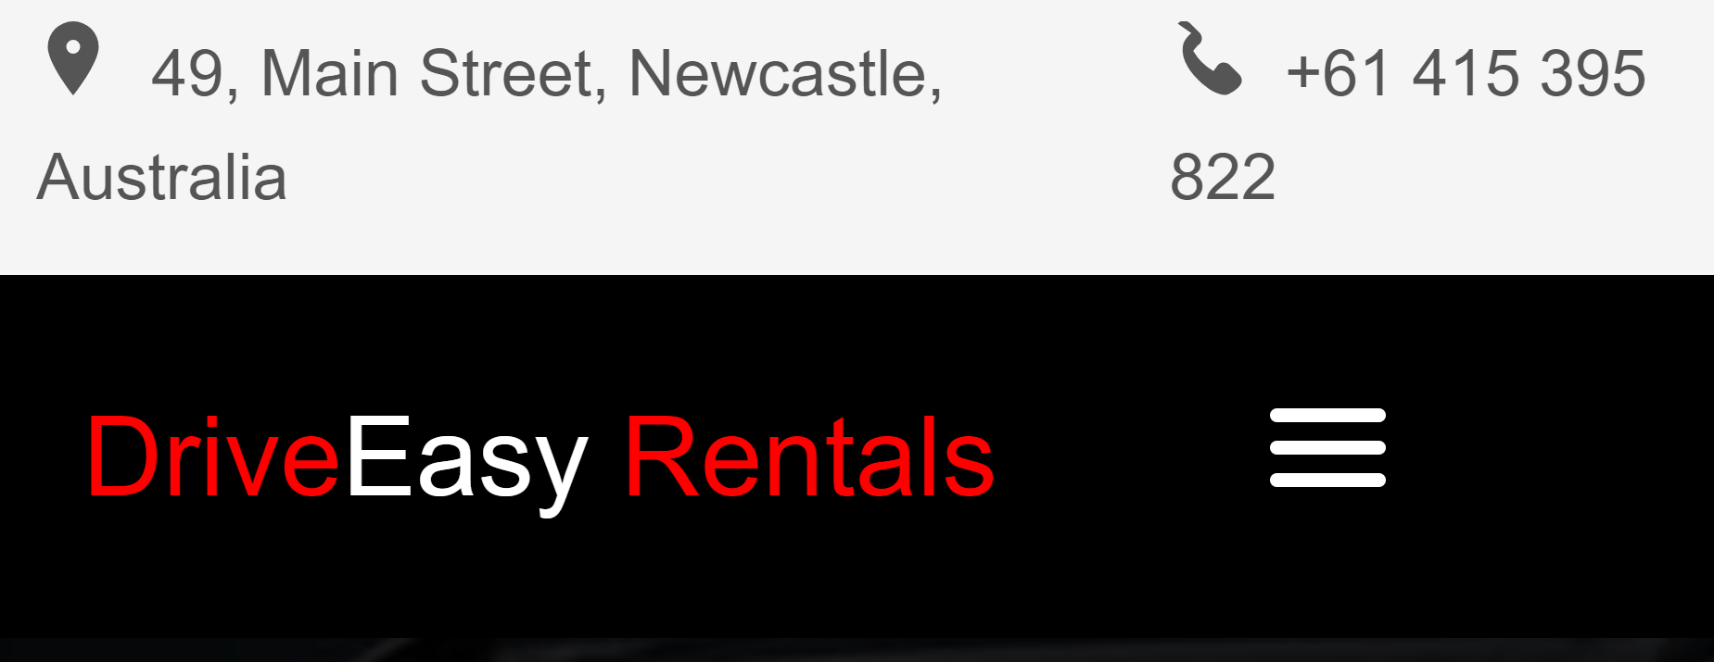

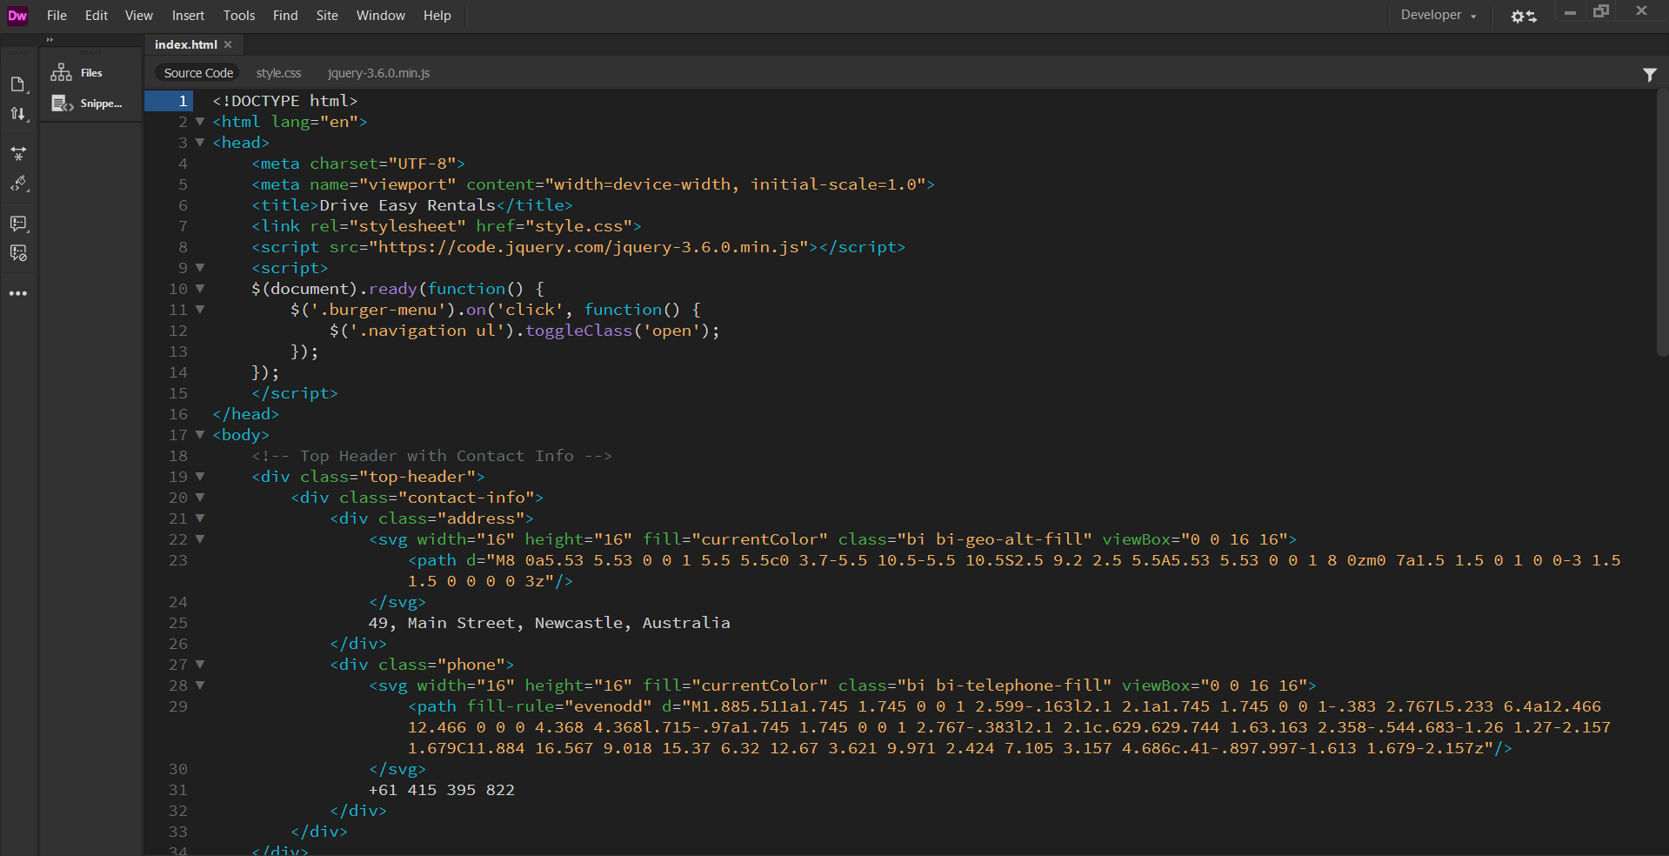

Screenshots were taken throughout the development process to document the progress and highlight key features of the Easy Drive Rentals website. Below are some examples of the visuals included in the report:

* Homepage Screenshot: Displays the final design of the homepage, showcasing the Easy Drive Rentals logo, navigation bar, and featured cars section. This screenshot highlights the clean and organized layout, which is designed to draw the user's attention to the most important aspects of the site.
* Wireframes to Final Design: A comparison between the initial wireframes and the final design, illustrating the evolution of the website’s layout. The wireframes provided a blueprint for the design, outlining the placement of key elements and the overall structure of the site. The final design builds on this foundation, adding color, images, and interactive features to create a polished and functional website.
* Responsive Design Example: Screenshots of the website as viewed on different devices, demonstrating how the layout adapts to various screen sizes. These screenshots show the website’s ability to maintain its functionality and visual appeal across a range of devices, from large desktop screens to small mobile phones.

These visuals help to illustrate the development process and the attention to detail that went into creating a polished final product. The progression from wireframes to the final design also highlights the importance of planning and iteration in web development.

**5.Reflection and Learning:**

The development of the Easy Drive Rentals website was a valuable learning experience, particularly in the areas of responsive design and user experience. One of the key takeaways was the importance of planning and testing for different devices. Media queries were instrumental in achieving a responsive design, and understanding how to implement them effectively was a crucial part of the learning process.

Another significant lesson was the challenge of balancing aesthetics with functionality. It was essential to create a visually appealing website that also performed well in terms of speed and usability. This required careful consideration of image sizes, CSS efficiency, and JavaScript functionality to ensure that the website was both beautiful and practical.

Feedback received during the design review phase was particularly helpful. Suggestions were made to improve the accessibility of the site, such as increasing text contrast and ensuring that all images had descriptive alt text. These changes were implemented, resulting in a more inclusive and user-friendly website.

The process of manually coding the website, without relying on AI tools, also provided a deeper understanding of the underlying technologies. This hands-on approach allowed for greater creativity and control over the final product, ensuring that the website met all the specified requirements and delivered a high-quality user experience.

Overall, the experience of building the Easy Drive Rentals website reinforced the importance of accessibility, responsiveness, and attention to detail in web development. The project was a successful exercise in applying these principles to create a website that meets the needs of its users and stands out in the competitive car rental market.

The challenges encountered during development, particularly in making the site responsive and accessible, provided valuable learning opportunities. These challenges were overcome through careful planning, testing, and iteration, resulting in a final product that is both functional and aesthetically pleasing.

**Conclusion:**

The Easy Drive Rentals website project was an opportunity to apply and refine web development skills, particularly in HTML, CSS, JavaScript, and responsive design using media queries. The focus on accessibility and usability ensured that the website is both inclusive and easy to navigate, providing a positive experience for all users. The challenges faced and the lessons learned during the development process have contributed to a deeper understanding of web design principles and best practices. This project serves as a solid foundation for future web development endeavors, with the knowledge gained from this experience being invaluable for continued growth in this field.